**Home Fixora**

**A PROJECT REPORT**

**for**

**Mini Project (K24MCA18P)**

**Session (2024-25)**

**Submitted by**

**Saurabh Kumar Singh**

**University Roll No. 202410116100189**

**Nitin Gangwar**

**University Roll No. 202410116100136**

**Praveen Kumar**

**University Roll No. 202410116100146**

**Submitted in partial fulfilment of the**

**Requirements for the Degree of**

**MASTER OF COMPUTER APPLICATION**

**Under the Supervision of**

**Ms. Divya Singhal**

**Assistant Professor**



**Submitted to**

**Department Of Computer Applications**

**KIET Group of Institutions, Ghaziabad**

**Uttar Pradesh-201206**

**(December 2024)**

**CERTIFICATE**

Certified that **Saurabh Kumar Singh Roll No. 202410116100189, Nitin GANGWAR Roll No. 202410116100136, Praveen Kumar Roll No. 202410116100146** has / have carried out the project work having “**Find Home Services/Repair**” (**Mini Project-1, K24MCA18P**) for **Master of Computer Application** from Dr. A.P.J. Abdul Kalam Technical University (AKTU**)** (formerly UPTU), Lucknow under my supervision. The project report embodies original work, and studies are carried out by the student himself/herself and the contents of the project report do not form the basis for the award of any other degree to the candidate or to anybody else from this or any other University/Institution.

**Saurabh Kumar Singh**

**(University Roll No- 202410116100189)**

**Nitin GANGWAR**

**(University Roll No- 202410116100136)**

**Praveen Kumar**

**(University Roll No- 202410116100146)**

This is to certify that the above statement made by the candidate is correct to the best of my knowledge.

**Date: 17/12/24**

**Ms. Divya Singhal Dr. Arun Kr. Tripathi**

**Assistant Professor Head**

**Department of Computer Applications Department of Computer Applications**

**KIET Group of Institutions, Ghaziabad KIET Group of Institutions, Ghaziabad**

# I

# ABSTRACT

In present scenario, people are busy in heavy work, as everyone is engaged with busy schedules, and hectic tasks which make them depart from family life. If any issues encounter unexpectedly, it distracts them and makes them choose over the work they have to accomplish primarily. It is important to manage both professional and family life. In such circumstances, every one of us would have visualized about a kind of house which doesn’t have any leaks in pipes, if it doesn’t have any mess in fixing a furniture and a kind of house which never face any maintenance issues and every one of us have thought that a life would be much better if no point of issue arises. It is difficult for customer to find any service in emergency at any time and place.

This website has so many advantages in our daily life because it makes the life of the people more convenient. So, giving a thought to that aspect of life is to design and develop a system that provides many services at your doorstep in just one click. A Website that provides variety of services like plumbers, carpenters, electricians, painters, and many more. To make it comfortable for all the users our website also provides a mobile environment which offers ease in accessing our services. A very simple process is carried out to book a service(s), and our website is specialized with providing a confirmation email about the selected service. Website is versatile as service can be booked from everywhere to anywhere you desire. Our website will provide a platform for all kind of house hold services at any time and place.

II

**ACKNOWLEDGEMENT**

Success in life is never attained single-handedly. My deepest gratitude goes to my project supervisor, **Ms. Divya Singhal** for her guidance, help, and encouragement throughout my project work. Their enlightening ideas, comments, and suggestions.

Words are not enough to express my gratitude to Dr. Arun Kumar Tripathi, Professor and Dean, Department of Computer Applications, for his insightful comments and administrative help on various occasions.

Fortunately, I have many understanding friends, who have helped me a lot on many critical conditions.

Finally, my sincere thanks go to my family members and all those who have directly and indirectly provided me with moral support and other kind of help. Without their support, completion of this work would not have been possible in time. They keep my life filled with enjoyment and happiness.

**Saurabh Kumar Singh**

**Nitin GANGWAR**

**Praveen Kumar**

III

# TABLE OF CONTENTS

|  |
| --- |
| Certificate I |
| Abstract II |
| Acknowledgements III |

|  |  |  |  |
| --- | --- | --- | --- |
| **Chapter 1: Introduction** | | | |
| 1.1 | Background | | 8 |
| 1.2 | Objectives | | 9 |
| 1.3 | Purpose, Scope and Applicability | | 10 |
|  | 1.3.1 | Purpose | 10 |
| 1.3.2 | Scope | 10 |
| 1.3.3 | Applicability | 10 |
| 1.4 | Achievements | | 11 |
| 1.5 | Organization of Report | | 12-13 |
| 1.6 | Functional Requirements | | 14 |
| 1.7 | Non-Functional Requirements | | 15 |
| **Chapter 2: Feasibility Study** | | | |
| 2.1 | **Market Analysis** | | 16-17 |
| 2.2 | Description of Chosen Technology | | 18-20 |
| **Chapter 3: Project Object** | | | |
| 3.1 | Problem Definition | | 21 |
| 3.2 | Requirements Specification | | 22 |
|  | 3.2.1 | Existing System | 22 |
| 3.2.2 | Proposed System | 23 |
| 3.3 | Planning and Scheduling | | 24 |
|  | **Chapter 4: Hardware and Software Requirement** | |  |
|  | 4.1 | Software Requirements | 25 |
| 4.2 | Hardware Requirements | 25 |
|  | **Chapter 5: Project Flow** | |  |

|  |  |  |  |  |
| --- | --- | --- | --- | --- |
|  | 5.1 | ERD Diagram | | 26-27 |
| 5.2 | Data Flow Diagram | | 28 |
| 5.3 | Use Case Diagram | | 29 |
|  | 5.3.1 | Admin Use Case Diagram | 29 |
|  | 5.3.2 | Customer Use Case Diagram | 30 |
| 5.4 | Sequence Diagram | |  |
|  | 5.4.1 | Admin Sequence Diagram | 31-32 |
|  | 5.4.2 | Customer Sequence Diagram | 33-34 |
| 5.5 | Activity Diagram | | 35 |
| **Chapter 6: Project Outcome** | | | | |
| 6.1 | Basic Modules | | | 36-37 |
| 6.2 | Data Design | | | 38 |
|  | 6.2.1 | Schema Design | | 38 |
|  | | 6.2.1.1 | Admin Table | 38 |
| 6.2.1.2 | Service Registration Table | 39 |
| 6.2.1.3 | Customer Table | 40 |
| 6.2.1.4 | Order Service Table | 40 |
|  | 6.2.2 | Data Integrity and Constraints | | 41 |
| 6.3 | Procedural Design | | | 42 |
|  | 6.3.1 | Logic Diagram | | 42 |
|  | 6.3.2 | Data Structures | | 42-43 |
|  | 6.3.3 | Algorithm Design | | 44 |
| 6.4 | User Interface | | | 45 |

|  |  |  |  |
| --- | --- | --- | --- |
|  | 6.4.1 | Home Page | 45 |
| 6.4.2 | Services | 45 |
| 6.4.3 | Customer Login Page | 46 |
| 6.4.4 | Customer Registration Page | 46 |
| 6.5 | Reference | | 47 |

**Chapter 1 Introduction**

## Background

In this fast-growing technology, our problems like plumbing, carpentry, painting, etc. need to be resolved soon. If we take the appointment of service provider which is not sure that we get the appointment of the service provider on time because as there are many problems which occur, like the service provider is busy somewhere else or he wants heavy cost for fixing the problem etc.

To overcome these types of problem we are going to make our website where the people get appropriate result. The interface of the website is very easy and anybody can easily work on it. This website can provide all the description and important information about the problem which the people are facing and looking for.

The Household service website is also very useful because the customer doesn’t have to visit to service provider’s office and also need not to ask anyone whether they have any mechanics in their contact as he/she can easily contact the mechanics via this website and he/she can also pay the payment online in this website if available. So, he/she can book order without facing any kind of difficulties.

To make this application work successfully we have used some latest technology such as PHP, HTML, CSS as the platform and My SQL as the database management environment. I have also included UML diagram which is beneficial to display the flow of process throughout the system so even an inexperienced people or newly people who recently settled in city can easily get the idea of this system.



Figure 1.1: The work of mechanics

## Objectives

The primary objective of this website is to get services easily on time and also customer can book multiple mechanics on time and get their issues solved. This paper discusses about main theme of the web home services, numerous services provided and the way the ordering and delivery of services takes place. Online system for household services are often employed by any authorized user meaning to search for household services through a clever web based system or a mobile application.

To provide users the beneficial mechanics in their respective area and also mechanics can register themselves to increase their work. Users just need to login with username and password which will be authenticated. To develop an internet based online system for opting household services and to develop a uniform mobile application for opting the services. To design a interactive interface for seeking services on the go. Customers will also get the confirmation of their particular booked mechanics whereas mechanics also get the confirmation that they have to reach to that particular customer.

## Purpose, Scope and Applicability

### Purpose

Where do you go when you need to fix your carpentry or air-conditioner in middle of the day? Or what happens if any of the pipe is leaking in kitchen or bathroom and is urgent to repair it?

Traditionally you would rush to your local electrician or plumber or would you ask for number and call for the reliable person. But now these issues is going to be solved sitting at home and getting all your work done easily. Our purpose is to solve the issues when the customer need these mechanics urgently and do not have any other option instead rushing here and there to find them.

### Scope

The scope of our project is to designing a complete website which provides easily available services. The main aim of the project is to provide an easy use website of services provided for customer which help customer to find things easily and don't face any difficulties to find any of mechanics.

We often get frustrated when we do not get any services on time and also often it happens that we call 2-3 service provider and any of them are not available on time which make us more irritated. So, through this website we will get rid of many such issues which would be convenient for customers and their issues get solved on time**.**

### Applicability

In this modern time, most of the people have access to internet services. Thus, a Home Services websites gives them the opportunity to get the services instantly at their location. Here this website provides everything as per customer requirements. The website will display a number of services providers which you are looking for.

## Achievements

**Time Saving:** Especially in metro cities, life has become so mechanical that people don’t have time for his or her personal life. With the assistance of online home service, you'll easily find the proper professional for your job. All would like to try is to call online home service provider or use their online platforms to book the actual service at your convenient time. This is able to save lot of your time and therefore the quality of the service would be great compared to the local service provider.

**New People in Town:** Online home service are considerably beneficial for working professionals and also very beneficial for the people that are recently relocated to the town because the people that are recently relocated to the town, they don’t know anyone therein area so through this website they will easily get all kinds of help they have.

**Quality Service:** The simplest part of the web services is Quality they promise and delivery. they are doing document verification of the partners and appearance at their past experience within the field. Sometime they also ask their few past customers to validate the work provided by the service partner.

**Multi-Tasking:** While online service provider takes care of all of your requirements, you'll relax or resume your work without disturbing your planner.

**Punctuality:** The time slots you choose for your requirements are going to be placed on high priority and therefore the service partners will reach the place on time and its best interest of the web service provider to send the service partners on time.

Get a confirmation

Login into website

Figure 1.2: The process of booking a mechanic.

Book that mechanic

And deal with him

Select a particular/multiple mechanic

## Organization of Report

This chapter has mainly focused on a brief description of the background and context of the project and its relation to work. It has given a concise statement of the aims and objectives of the project, answers questions on why this project is being done, how the project could improve the system its significance and theoretical framework, what are the main issues being covered in the project, what are the main functions of the project, and how this project will serve the computer world and people. This chapter will also explain what knowledge the student has achieved after the completion of the work, what contributions has the project made to the chosen area. It will also state the goals achieved describing the degree to which the findings support the original objectives laid out by the project.

In the 2nd chapter, Survey of Technologies, I will highlight my collective awareness and understanding of available technologies related to the topic of the project. I will also give the detail of all the related technologies that are necessary to complete the project and are available in the chosen area. I will also present a comparative study of all those available technologies and explain why selected the one technology for the completion of the objectives of the project.

The 3rd chapter, Requirements and Analysis, will define the problem on which I am working and will provide details of the overall problem in the project. In this phase I will also define the requirements of the system, independent of how these requirements will be accomplished, describe the things in the system and the actions that can be done on these things, and identify the operation and problems of the existing system. The way I have planned to complete the project will be shown by with the help of Gantt Chart. This will describe how I have scheduled my whole project completion. It will also give the details of all the software and hardware needed for the development and implementation of the project. Lastly, I will

explain the problem domain and produce a model of the system, which describes operations that can be performed on the system, and the allowable sequences of those operations.

The 4th chapter of the project will describe the desired features and operations in detail, including screen layouts, business rules, process diagrams, and pseudocode. I will divide the overall problem into more manageable parts and develop each part or module separately. When all modules are ready, I will integrate all the modules into one system. In this phase, I will briefly describe all the modules and the functionality of these modules. In user interface, I will describe the external and internal components and the architecture of user interface. I will also include real-time considerations and security issues related to the project and explain how I intend avoiding those security problems. The test cases, will provide easy detection of errors and mistakes with in a minimum period and with the least effort.

The 5th chapter, Implementation and Testing, will define the plan of implementation, and the standards that I would be using in the implementation. The code will include only the important codes (algorithms, applets code, forms code etc). It will also include the testing approaches, modifications and improvements that I have done to my project over the course of time.

The 6th chapter, Results and Discussion, will explain the test results and reports based on the test cases, which should show that the project can face any problematic situation and that it works fine in different conditions. The results will be discussed with different scenarios which will in turn help to determine the success rate of the project.

The 7th chapter, Conclusions, brings together the limitations encountered during the testing of the project and how they can be eliminated in the future. It also enlists the criticisms accepted during the demonstrations of the project. It will also include the future scope of the project describing two things: firstly, new areas of investigation prompted by developments in this project, and secondly, parts of the current work that were not completed due to time constraints and/or problems encountered.

### Functional Requirements

* Enhancement to the online booking system will primarily provide a more precise services management tool that will establish easy and fast services to customers, and thus allowing customers to feel a greater level of confidence in booking. Appropriate behavior and the functionality of a system and there is often a tight correspondence between requirements and particular functions of the solution system.
* The following represents a list of functional requirements for the online booking of home services:
* The system must provide customer with accurate details of the mechanics.
* Ease of GUI use that can be accessed via web browser must be established.
* The system must follow technical development standards supported on known operating systems such as Windows, Linux, and UNIX, in addition to future operating systems versions.
* Backup data restore capabilities should be granted.
* The system must provide data integrity checks to ensure data remains consistent and updated.

### Non - Functional Requirements

* Nonfunctional requirements are requirements that are not specifically concerned with the functionality of a system. They normally place restrictions on the product being developed and the development process. Nonfunctional requirements may be regarded as parameters of functionality in that they determine how quickly, how accurately, how reliably, how securely, etc., functions must operate.
* Some of the online booking of home services system’s Non - Functional requirements are as follows:
* Response and net processing time must be acceptable by user and by application.
* When checking the database for errors, a 100% scan of the data is required, rather than selecting a sample set.
* The system must be working at 100% peak efficiency during the booking process.
* The system should be allow adding more customers to allow better services.
* The system should provide friendly graphical Interface to ensure ease of use when end users utilize system functionality.

**Chapter 2**

**Feasibility Study**

## ****2.1 Market Analysis****

### ****2.1.1 Industry Insights****

The home services market has experienced significant growth due to increased demand for professional services and the convenience of digital solutions. Busy lifestyles and the rise of the gig economy have contributed to this trend.

### ****2.1.2 Target Audience****

* **Homeowners:** Individuals seeking professional assistance for home repairs and maintenance.
* **Renters:** Tenants in need of short-term or urgent fixes.
* **Property Managers:** Managing multiple properties requiring regular upkeep.

### ****2.1.3 Competitive Landscape****

* Key competitors include Angi (formerly Angie’s List), Thumbtack, TaskRabbit, and HomeAdvisor. These platforms dominate the market but often lack localized service focus and personalized customer experiences. This project aims to bridge those gaps by emphasizing quality, trust, and ease of use.

## ****2.2 Technical Feasibility****

### ****2.2.1 Platform Features****

* **Search and Discovery:** Filter by service type, location, price, and ratings.
* **Booking System:** Real-time scheduling and confirmation.
* **User Reviews:** Transparent ratings and feedback.
* **Payment Integration:** Secure online payments with options for installments.

### ****2.2.2 Service Provider Features****

* **Profile Management:** Showcase skills, certifications, and service offerings.
* **Job Dashboard:** Accept or reject service requests and track payments.
* **Analytics Tools:** View performance metrics and customer feedback.

### ****2.2.3 Admin Features****

* **User Management:** Oversee customer and provider accounts.
* **Service Quality Monitoring:** Flag low-performing providers.
* **Reports and Analytics:** Generate insights for business decisions.

### ****2.2.4 Technology Stack****

* **Frontend:** React.js or Angular for responsive design.
* **Backend:** Node.js or Django for server-side functionality.
* **Database:** PostgreSQL or MongoDB for storing user data and transactions.
* **Cloud Hosting:** AWS or Google Cloud for scalability.
* **Payment Gateways:** Stripe or PayPal for secure transactions.

### ****2.2.5 Development Phases****

* **Phase 1:** Requirements gathering and platform design.
* **Phase 2:** MVP development (core features).
* **Phase 3:** Testing and debugging.
* **Phase 4:** Launch and user onboarding.

## ****2.3 Financial Feasibility****

### ****2.3.1 Initial Costs****

* **Platform Development:** $50,000-$150,000.
* **Marketing and Branding:** $10,000-$30,000.
* **Operational Setup:** $5,000/month for hosting, support, and maintenance.

### ****2.3.2 Revenue Model****

* **Commission:** Percentage fee on every transaction.
* **Subscription Plans:** Premium features for homeowners and service providers.
* **Advertisements:** Paid listings and promotions for service providers.

### ****2.3.3 Financial Projections****

* **Year 1:** Revenue break-even by onboarding 500 providers and 5,000 users.
* **Year 2:** 25% revenue growth with geographic expansion.
* **Year 3:** Achieve profitability through increased user base and upselling premium services.

**2.4 Market Feasibility**

### ****2.4.1 User Demand****

* Survey results indicate a strong demand for a platform that simplifies finding reliable home service providers. Users prefer transparency, quality assurance, and ease of use, which are often missing in existing solutions.

### ****2.4.2 Competitive Differentiation****

* The platform will focus on localized service providers, rigorous vetting processes, and customer-centric features to differentiate itself from competitors.

**2.5 Description of Chosen Technology**

**2.5.1 HTML**

* HTML stands for Hypertext Markup Language.HTML files are saved with
* .html extensions. It creates and describes the structure of web pages. It consists of series of elements. All elements instruct the browser of how to the web page should look like. HTML elements are from start tag to end tag. The purpose of a web browser is to read HTML documents and display them correctly and in correct order. HTML elements can be building block of HTML pages.
* HTML can be assisted by CSS (Cascading Style Sheet) and also scripting language such as JavaScript. Web browsers receive HTML documents from a web server or from local storage and render the documents into multimedia web pages. HTML provides a means to create structured documents by denoting structural semantics for text such as headings, paragraphs, lists, links, quotes and other items. HTML elements are defined by tags which are used inside the angular brackets.
* Tags such <img>, <links>, etc. are directly directed to the next page. Other tags such as <p> provide information about document text and may include other tags as sub-elements. Browsers do not display the HTML tags, but use them to interpret the content of the page.

**2.5.2 CSS**

* CSS stands for Cascading Style Sheet. CSS files are saved with .css extensions. CSS is used for describing the presentation of the document written on markup page which is HTML. It is technology of World Wide Web along with HTML and JavaScript.
* CSS is designed for the separation of design and content. It helps to design the background of the page, layout, and font of the parting paragraph. This separation can provide more flexibility and enable multiple web pages to share formatting by specifying the relevant CSS in a separate .css file which reduces complexity and
* repetition in the content as well as enabling the .css file to improve the page load speed between the pages that share the file and its formatting.
  1. **Microsoft SQL Server**

**2.6.1 Relational database management**

* A relational database management system uses only its relational capabilities to manage the information stored in its database.

**2.6.2 Information Representation**

* All information stored in a RDBMS is represented only by data item values, which are stored in the tables that makeup the database.

**2.6.3 Logical Accessibility**

* Every data item value stored in a relational database is accessible by stating the name of the table it is stored in, the name of the column under which it is stored and the value of the primary key that defines the row in which it is stored.
* Representation of Null Values
* The database management system has a consistent method for representing null values. For example, null values for numeric data must be distinct from zero or any other numeric value and for character data it must be different from a string of blanks or any other character value.

**2.6.4 Catalog Facility**

* The logical description of the relational database management system is represented in the same manner as ordinary data. This is done so that the facilities of the relational database management system itself can be used to maintain database description.

**Data Language**

* A relational database management system may support many types of languages for description data and accessing the database. However, there must be at least one language that uses ordinary character strings to support the definition of data, the definition of views, the manipulation of data, constraints on data integrity, information concerning authorization and the boundaries for recovery of units.

**View Updating**

* Any view that can be defined using combinations of base tables, that are theoretically updateable, is capable of being updated by the relational database management system.
* Insert, Update and Delete:
* Any operand that describes the results of a single retrieval operation is capable of being applied to an insert, update or delete operation as well.
* Physical Data Independence
* Changes made to physical storage representations or access methods do not require changes to be made to application programs.

**Chapter 3**

**Project Object**

## 3.1 Problem Definition

The truth of the manual process of finding mechanics becomes difficult in day to day life. Usually correctness, robustness to fraudulent behaviors, coherence, consistency, security are all key requirements for the integrity of booking process. Booking system must be sufficiently robust to withstand a variety of fraudulent behaviors, must be sufficiently transparent and comprehensible that the customers find it easy.

There are several service booking systems available all over the world with each of them having its peculiar problems. The manual booking system still appears prominent among the developing nations. In traditional booking system, customers can choose or mark their choices of mechanics and call them to resolve their issues, which are sealed and officially opened under special conditions to warrant transparency. The calling mechanics manually, which is a tedious process that is subject to human error.

This method of booking has littered history with examples of mechanics being manipulated to influence their outcome.

Furthermore, the cost and process of manual booking of services are both increasing geometrically and tedious to execute and there has been a declining participation rate due to: inconvenience of manual system of booking services like, mechanic is not available at that time, new people who came to stay and also town is new for them so they get difficulty in finding the mechanics, if the mechanics charges high price and demand for the more, also when the mechanics does not behaves properly with customers, also some mechanics charges low and after doing their work they charge higher prices.

**3.2 Requirements Specification**

**3.2.1 Existing System**

In many parts of our country people cannot find mechanics around them because of several reasons. To illustrate, sometimes people may not be in their own registration region and due to this fact, they are not able to find mechanics or are not able to contact them. In the present system there is no such application level system provisions in the country to find mechanics and procedure as a whole. Also, in the present status, there is no such application in use for online mechanics help and getting problems solved very easily and effectively structure existing in the country. All the step by step procedures are carried out by the registered mechanics and also when their details are provided with the correct information and job that they do. The fact is all the procedures are carried out manually, starting from the registration process to result of booking.

If this process is done manually it wastes a lot of time and money. Thus, the present system proves itself to be an inefficient one. The existing system is not web based. The user or person must register themselves and then book the mechanic as per their needs and use.

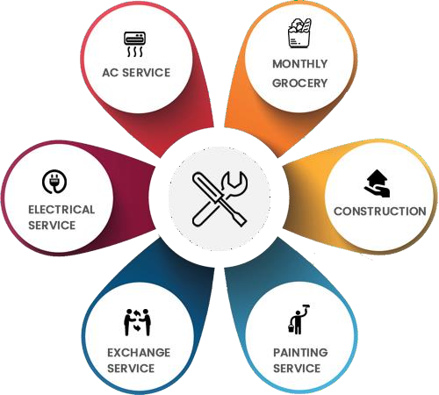

Figure 3.2.1: Services provided by Mechanics

**3.2.2 Proposed System**

* The design of any online mechanics helping system, whether electronic or manual, must satisfy several sometimes-competing criteria including a high degree of security and accuracy, eligibility and authentication, integrity, verifiability and auditability, reliability, flexibility, performance and scalability.
* As India is moving towards the Digital India and the conventional findings of the mechanics is very difficult for new people to adjust with this if any problems occur. The new implemented website protocol has two main players: The customer and the administrator sections. The customer (which can be found at home, in a working station, or any other device have the function of booking). The administrator performs the function of mechanics registration, validation of customer, database and booking the service.
* The main advantages of the new protocol are the following:
* Customer finds it easy as they need not to find them anywhere else.
* Inured to manual troubles like mechanics not available or he his on holiday.
* Possibility of configuration for different bookings of the services at a particular time.
* Furthermore, it is assumed that a trustworthy Administrator is available. Apart from that, the accessibility to the customer in booking the procedure plays a special role, which means that the booking result can be monitored and mechanics gets the work to go that to that house and do his work. Accessibility to the customer is necessary for all booking stages.
* The system is to cater for the following generic requirements:
* *Privacy:* After customer login with username and password their login-info should not get revealed or else there are chance of getting their account hacked.
* *Accuracy:* Customer should book only what kind of service is been needed. They shouldn’t book the services which is not in their use.

**3.3 Planning and Scheduling**

A Project Plan is defined as a management summary that describes the essentials of a project in terms of its objectives, justification and how the objectives are to be achieved. It describes how all the major activities under each project management function are to be accomplished, including that of overall project control.

Planning of a system involves the modularization of the project in a definite number of stages and creating a sequence of activities to be performed. The entire project can be viewed as several independent modules. These modules follow chronological sequence. They are:

1. Preliminary studies and investigation.
2. Data gathering or Systems study.
3. System analysis.
4. Synopsis.
5. Development of Software and Testing.
6. Implementation and Evaluation.

Project scheduling is one of the critical management tasks as it dictates the time frames in which the project will be completed, in terms of resource requirements and the sequence of tasks to be completed. Project scheduling is defined as the process of determining when project activities will take place depending upon defined durations and precedent activities. Schedule constraints specify when an activity should start or end, based on duration, predecessors, external predecessor relationships, resource availability, target dates or other time constraints. Project scheduling is a complex and iterative task.

Scheduling refers to the time needed to conduct systems investigations, formulate the logical design, code the software and prepare files, develop test data, test the software and install it. In other words, each activity is associated with the project development requires an amount of time that must be correctly estimated and incorporated in the project schedule.

**Chapter 4**

**Software and Hardware Requirements**

### Hardware Requirements

* Processor: Intel Pentium IV and above
* RAM: 1GB or more
* Hard disk 250 GB and more

### Software Requirements

* Operating System:
  + Microsoft Windows
  + Smart Phone: 2 GB RAM and 8 GB and more ROM
* Front End:
  + JS, CSS, HTML.
* Back End:
  + Mongodb
  + Nodejs

**Others:**

1. Web Browser: Internet Explorer, Google Chrome.

**Documentation:**

* + Microsoft Word 2010 and above
  + Microsoft Excel 2010 and above

**Chapter 5**

**Project Flow**

**5.1 Entity-Relationship Diagram**

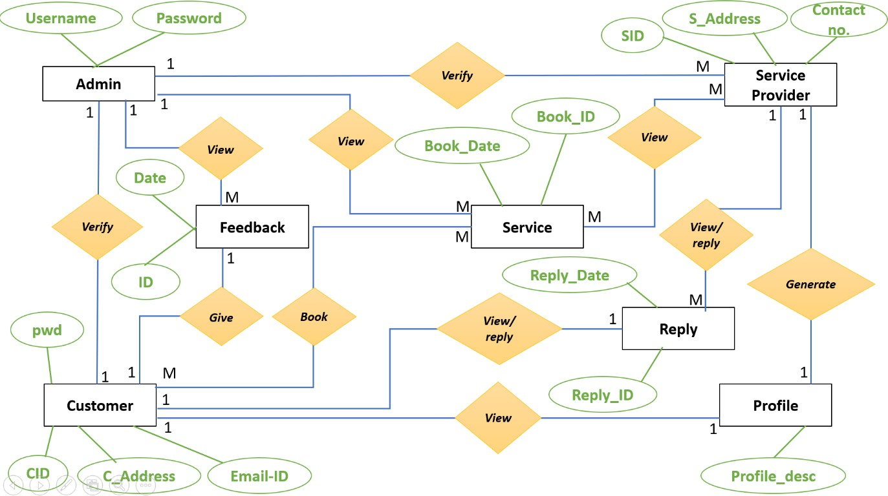

Figure 5.1: E-R Model of the project

The diagram depicts an Entity-Relationship (E-R) model, which is a way to visually represent the relationships between different entities (data objects) in a database. In this case, it seems to be a model for a booking and reservation system.

Entities:

* Admin: Represents the administrators of the system. It has attributes for Username, Password, and possibly other admin-specific details.
* Customer: Represents the users of the system who make bookings. It has attributes for CID (Customer ID), C_Address (Customer Address), Email-ID, and possibly other customer details.
* Service Provider: Represents the entities that provide services. It has attributes for SID (Service Provider ID), S_Address (Service Provider Address), Contact_no, and possibly other service provider details.
* Service: Represents the services offered by the service providers. It has attributes for Book_ID (Booking ID), Book_Date, and possibly other service-specific details.
* Feedback: Represents feedback provided by customers about services. It has attributes for ID (Feedback ID), Date, and possibly other feedback details.
* Reply: Represents replies to customer feedback. It has attributes for Reply_ID (Reply ID), Reply_Date, and possibly other reply details.
* Profile: Represents the profile information of customers and service providers. It has attributes for Profile_desc (Profile Description) and possibly other profile details.

**Relationships:**

* Admin - Verifies: An admin can verify multiple services.
* Customer - Gives Feedback: A customer can give feedback on multiple services.
* Customer - Books: A customer can book multiple services.
* Service Provider - Provides Service: A service provider can provide multiple services.
* Service - Receives Feedback: A service can receive multiple feedbacks.
* Service - Receives Reply: A service can receive multiple replies to its feedback.
* Customer/Service Provider - Has Profile: A customer or service provider has a profile.
* Cardinalities:
* The numbers on the relationship lines indicate the cardinality of the relationships. For example, "1" means one, and "M" means many.
* Additional Notes:
* The pwd attribute on the Customer entity might represent the customer's password.
* The Verify and View/Reply relationships might represent actions performed by admins on services and feedback.
* The Generate relationship might represent the generation of profiles for customers and service providers.
* Interpretation:
* This E-R model represents a system where admins can verify services, customers can book services and provide feedback, service providers can offer services, and the system can generate profiles for customers and service providers. The model also allows for feedback and replies to be associated with specific services.
* Let me know if you have any further questions or would like to explore a specific aspect of the model in more detail.

### 5.2 Data Flow Diagram

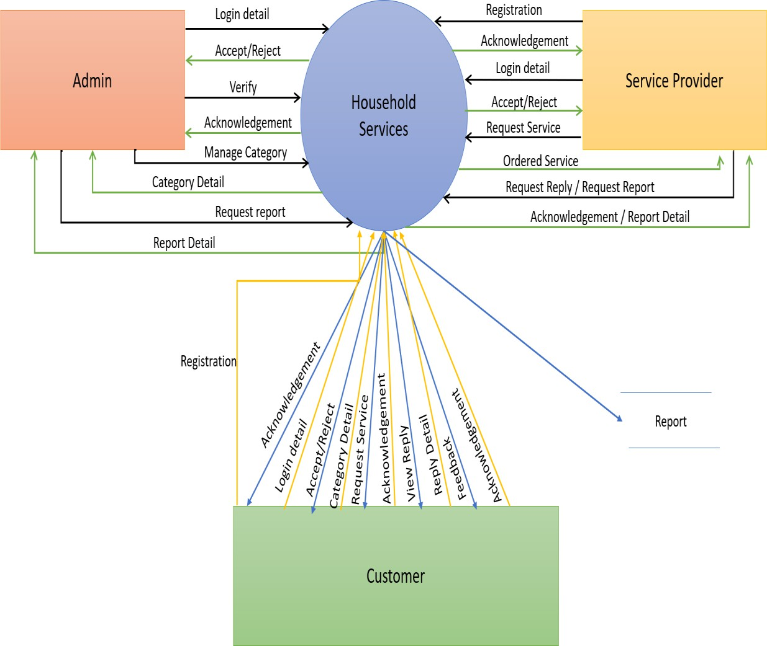

Figure 5.2: Data Flow Diagram of the project

This is a Data Flow Diagram (DFD) for a Household Services system. It visualizes the flow of data between different entities or actors involved in the system.

Here's a breakdown of the diagram:

**Entities/Actors:**

* Admin: Responsible for managing categories, verifying service providers, and generating reports.
* Service Provider: Provides services to customers based on their requests.
* Customer: Requests services, receives acknowledgements, and provides feedback.

**Data Flows:**

* Customer to Household Services:
* Registration: Customer registers with the system.
* Login Detail: Customer logs in to access services.
* Request Service: Customer requests a specific service.

**5.3** **Use Case Diagram**

### 

### 5.3.1 Admin Use Case Diagram

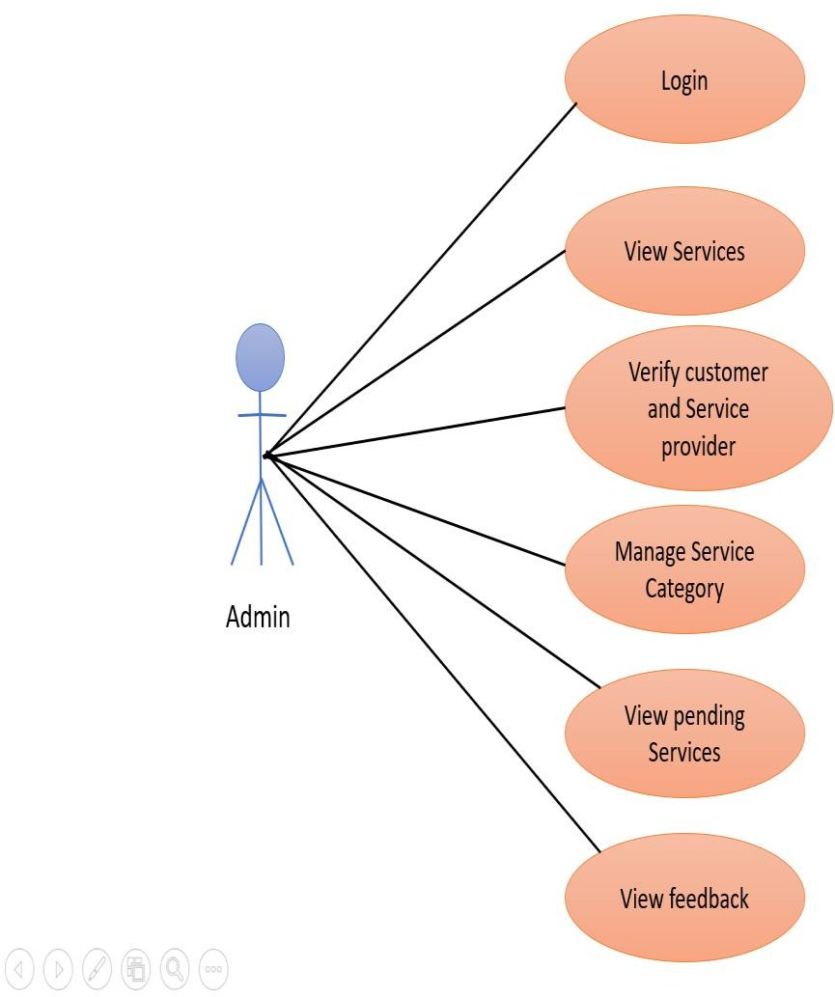

Figure 5.3.1: Admin Use Case Diagram of the project

This image shows us a Use Case Diagram for an Admin role, illustrating the main functionalities that the admin can perform within a system. Here's a breakdown of the diagram:

Actor: The "Admin" is represented as a stick figure. This symbolizes the user interacting with the system.

Use Cases: These are the system functions or activities available to the Admin. They are shown as ovals and connected to the Admin via straight lines:

* Login: The admin logs into the system.
* View Services: The admin can view the available services.
* Verify Customer & Service Provider: The admin verifies customer details and service provider information.
* Manage Service Category: The admin manages and organizes service categories.
* View Pending Services: The admin can review pending or incomplete services.
* View Feedback: The admin can view feedback submitted, possibly by customers or other users.

**5.3.2** **Customer Use Case Diagram**

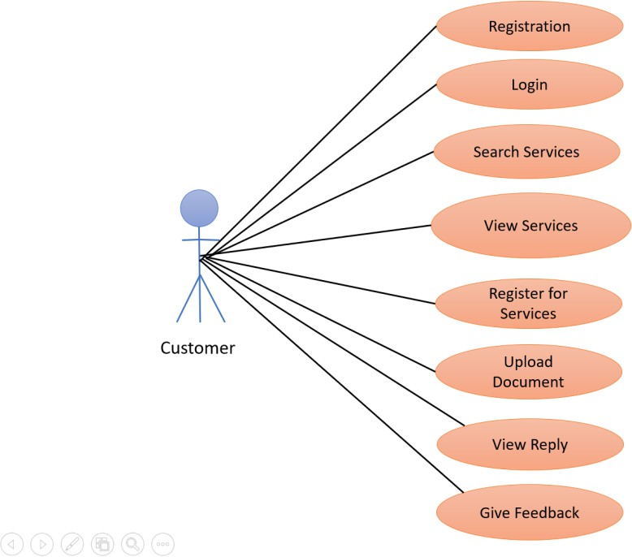

Figure 5.3.2 Customer Use Case Diagram of the project

This diagram is a Customer Use Case Diagram for a system. It focuses on the interactions between a Customer and the system, illustrating the various actions or use cases that the customer can perform.

Here's a breakdown of the diagram:

Customer (Actor): The central figure represents the customer, the user who interacts with the system.

Use Cases (Ovals): The ovals surrounding the customer depict the different actions or functions that the customer can perform within the system. These include:

* Registration: The customer can create a new account in the system.
* Login: The customer can log in to their existing account.
* Search Services: The customer can search for available services within the system.
* View Services: The customer can view details about specific services.
* Register for Services: The customer can register for desired services.
* Upload Document: The customer can upload required documents or information.
* View Reply: The customer can view replies or updates related to their service requests or queries.
* Give Feedback: The customer can provide feedback or ratings about the system or services.

Relationships (Lines): The lines connecting the customer to the use cases indicate the association between the customer and the actions they can perform.

Overall, this diagram provides a visual representation of the customer-centric perspective of system. It highlights the functionalities that customer can interact with and actions they can take within the system.

**5.4 Sequence Diagram**

**5.4.1 Admin Sequence Diagram**

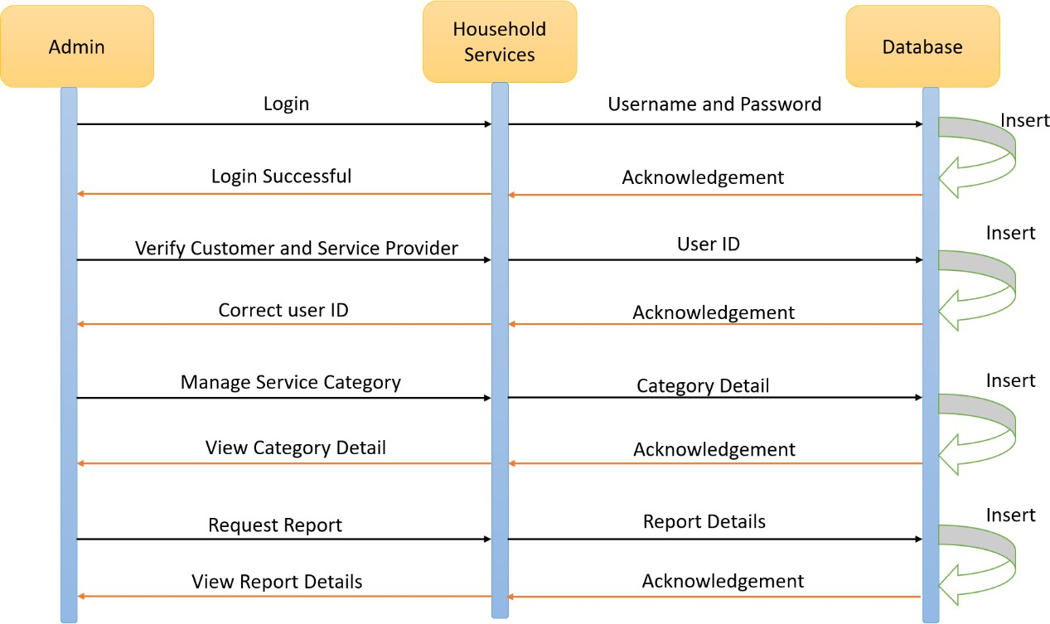

Figure 5.4.1: Admin Sequence Diagram of the project

This is a Sequence Diagram that illustrates the interactions between different components or systems in a Household Services application, specifically focusing on the actions performed by the Admin.

**Key Elements in the Diagram:**

* Lifelines: The vertical lines represent the different components involved in the interactions. In this case, we have:
* Admin
* Household Services
* Messages: The arrows indicate the messages or interactions between the components. The direction of the arrow shows the direction of the message.
* Sequence of Actions:
* Login: The Admin initiates the interaction by sending a Login message to the Household Services component.
* Username and Password: The Household Services component requests the Username and Password from the Admin.
* Acknowledgement: After receiving the credentials, the Household Services component sends an acknowledgement message to the Admin.
* Insert: The Household Services component then inserts the user ID into the Database.
* Verify Customer and Service Provider: The Admin sends a message to verify the customer and service provider.
* Correct User ID: The Household Services component verifies the user ID and sends a confirmation message to the Admin.
* Manage Service Category: The Admin sends a message to manage the service category.
* Category Detail: The Household Services component provides the category details to the Admin.
* Acknowledgement: The Admin acknowledges the receipt of the category details.
* View Category Detail: The Admin requests to view the category details.
* Acknowledgement: The Household Services component provides the category details to the Admin.
* Request Report: The Admin requests a report.
* Report Details: The Household Services component provides the report details to the Admin.
* View Report Details: The Admin requests to view the report details.
* Acknowledgement: The Household Services component provides the report details to the Admin.
* Overall, this Sequence Diagram shows the steps involved in the Admin's interaction with the Household Services application, including login, user verification, managing service categories, and generating reports.

**5.4.2 Customer Sequence Diagram**

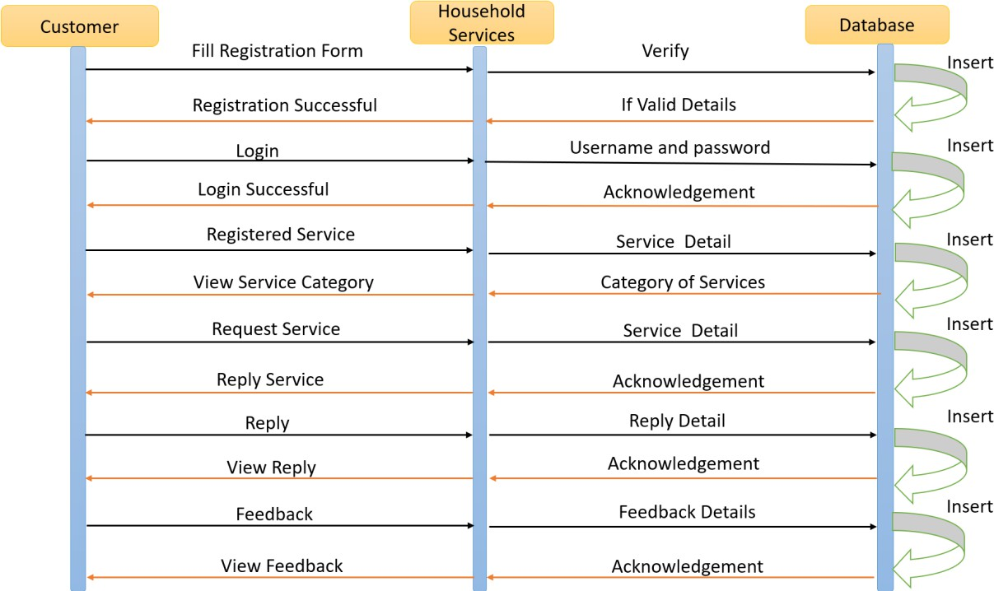

Figure 5.4.2: Customer Sequence Diagram of the project

This is a Sequence Diagram for a Customer Service system. Sequence diagrams are used in software engineering to visualize the interactions between different objects or components in a system over time.

Here's a breakdown of the diagram:

Objects Involved:

* Customer: The end-user of the system.
* Household Services: The system that provides household services.
* Database: The storage for user data, service requests, replies, and feedback.

**Interactions:**

* Registration:
* The customer fills out a registration form.
* The Household Services system verifies the details.
* If the details are valid, the customer is registered in the database.
* Login:
* The customer logs in using their username and password.
* The system acknowledges a successful login.
* Service Category View:
* The customer views the available service categories.
* Service Request:
* The customer requests a specific service.
* Reply:
* The Household Services system sends a reply to the customer.
* Feedback:
* The customer provides feedback on the service.
* Key Points:
* The arrows indicate the direction of messages between objects.
* The vertical lines represent the lifelines of the objects.
* The boxes along the lifelines show the activities performed by the objects.
* This sequence diagram illustrates the typical interactions a customer has with a household services system. It shows the steps involved in registration, login, service request, reply, and feedback.

**5.5 Activity Diagram**

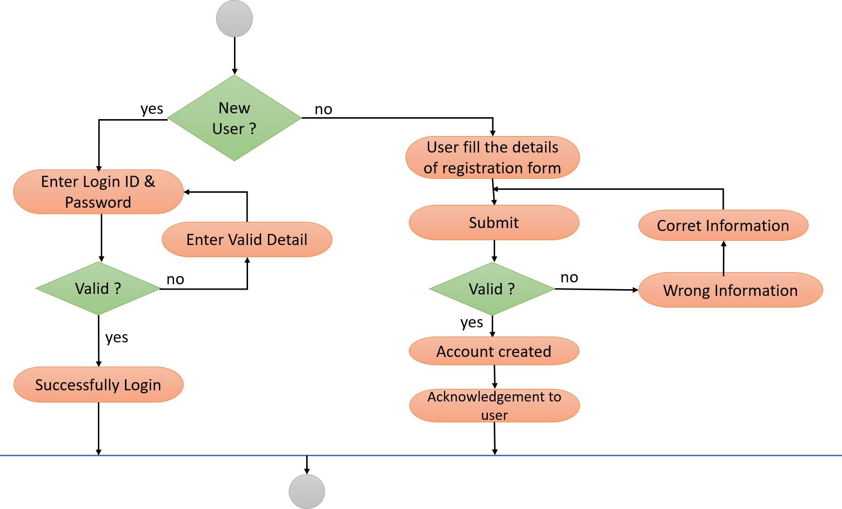

Figure 5.5: Activity Diagram of the Login and Registration

The image you've provided is an Activity Diagram. This type of diagram is used in software engineering to model the flow of control in a system. It focuses on the sequence of activities and the decisions that determine the flow.

Let's break down the diagram you provided:

Objects and Flow:

* Start: The process begins here.
* New User? The first decision point. It asks whether the user is new or an existing user.
* Yes (New User): If the user is new, they are directed to "User fill the details of registration form." After filling the form, they "Submit" the information.
* Valid? Another decision point. It checks if the submitted information is valid.
* Yes (Valid): If the information is valid, an "Account created" message is displayed, & an
* "Acknowledgement to user" is sent.
* No (Invalid): If the information is invalid, a "Wrong Information" message is displayed.
* No (Existing User): If the user is not new, they proceed to "Enter Login ID & Password."
* Valid? Another decision point. It checks if the entered login credentials are valid.
* Yes (Valid): If the credentials are valid, a "Successfully Login" message is displayed.
* No (Invalid): If the credentials are invalid, the process likely ends or redirects the user to retry.

**Chapter 6**

**Project Outcome**

* 1. **Basic Modules**

**Administrator**

In this administrator module the service provider or admin having the authorization to access this one. Admin is the super user of the system. In this module admin or service provider will get the requests from the customers. In this module admin will receive the all registration request from users. These requests will be scrutinized by admin that will be sending to concerned field mechanics for further verification. By checking verification details from the field mechanics, the admin will take decision like accept. Admin should give the acceptance to the customer those who have send for booking the service register. Customer’s acceptance will be finalized by the admin itself. Administrator can view the all users, customer’s in the form of reports.

**Registration Module**

This is a module through which general user as well as customer’s will be registered by admin. The user should provide the Entire information about him regarding name, contact number, etc. User should upload his / her image at the time of registration. Also, the details filled by customer’s and respective service provider should be accurate.

**Customer Module**

It will be providing interface to the customer. By this, customers can access the system. Credentials will be provided by admin. By using these credentials customers can enter home page. In this module service provider can manage his personal data. Service provider will get

the queries from admin of user registration request for further verification. Customer’s will send reply to the queries to the admin.

**Service Provider Module**

To the registration as Service provider, then the mechanics should be registered first. The service provider registration request goes to admin. The acceptance will be given by admin only. Customers can enter his home page by using his credentials that was accepted by admin. In this module customers can view all the details about the service provider like occupation, name, address, etc. this helps customer to book their mechanics as per their requirements. Also, this benefits customer to know where the mechanics works and whether the mechanics is in his area or is somewhere far away.

**Reports**

This module comes under admin module as sub module. By the admin can know entire details about customer registration and different mechanics occupation wise. By this admin can know who has booked which services

**Authentication Module**

This module contains all the information about the authenticated users. User without his username and password can’t enter the login. If he / she is an authenticated user, only then he / she can enter to his / her login and then he / she will have authorization based upon their roles.

**6.2 Data Design**

A database design is a collection of stored data organized in such a way that the data requirements are satisfied by the database. The general objective is to make information access easy, quick, inexpensive and flexible for the user. There are also some specific objectives like controlled redundancy from failure, privacy, security and performance. A collection of relative records makes up a table. To design and store data to the needed forms database tables are prepared.

* + 1. **Schema Design**

**6.2.1.1Admin Table**

Table 6.2.1.1 Admin Table

|  |  |  |
| --- | --- | --- |
| Column | Type | Integrity Constraints |
| Username | Varchar (50) | PRIMARY KEY |
| Password | Varchar (10) | NOT NULL |
| Name | char | NOT NULL |

**6.2.1.2 Service Registration Table**

Table 6.2.1.2 Registration Table

|  |  |  |
| --- | --- | --- |
| Column | Type | Integrity Constraints |
| Sid | Int (10) | PRIMARY KEY |
| Name | Varchar (50) | NOT NULL |
| Address | Varchar (255) | NOT NULL |
| City | Varchar (50) | NOT NULL |
| State | Varchar (50) | NOT NULL |
| Mobile No | Varchar (50) | NOT NULL |
| Email ID | Varchar (50) | NOT NULL |
| Password | Varchar (10) | NOT NULL |
| Service rate | Int (10) | NOT NULL |
| Status | Varchar (20) | NOT NULL |
| Cat_Id | Varchar (50) | FOREIGN KEY |

**6.2.1.3 Customer Table**

Table 6.2.1.3 Customer Table

|  |  |  |
| --- | --- | --- |
| Column | Type | Integrity Constraints |
| C_ID | Int (10) | Primary key |
| C_Name | Varchar (50) |  |
| Address | Varchar (255) |  |
| City | Varchar (50) |  |
| State | Varchar (50) |  |
| Mobile_No | Int (10) |  |
| Email_ID | Varchar (50) |  |
| Password | Varchar (10) |  |
| Status | Varchar (50) |  |

**6.2.1.4 Order Service Table**

Table 6.2.1.4 Order Service Table

|  |  |  |
| --- | --- | --- |
| Column | Data Type | Indexes |
| Order_ID | Int (10) | Primary Key |
| C_ ID | Int (10) | Foreign Key |
| S_ ID | Int (10) | Foreign Key |
| Description | Int (10) |  |
| Address | Varchar (255) |  |
| City | Varchar (50) |  |
| Mobile_No | Varchar (10) |  |
| Book_Date | Date |  |
| QR Code | Varchar (20) |  |
| Status | Varchar (10) |  |

**6.2.2 Data Integrity and Constraints**

Data integrity is used to maintain accuracy and consistency of data in a table. The classification of data integrity is:

* *Pre-Defined Integrity:* We can implement this using constraint. This is further divided into three categories –
  + *Entity Integrity:* This integrity ensures that each row in a table is uniquely identified entity. We can apply entity integrity by specifying primary key, unique key and not null.
  + *Referential Integrity:* This integrity ensures the relationship between the tables. We can apply this using foreign key constraints.
  + *Domain Integrity:* this integrity ensures the data values in a database follow defined rules for values, range, and format. A database can be checked using these rules and using Check and Default constraints.
* *User Defined Integrity:* We can implement this using triggers.

Constraints are used for validating or restricting data. These are mainly used to restrict data from table. Main three types of constraints in SQL Server are:

* *Default:* Default constraints are used to assign the default value to the particular column in the table. A table can contain any number of default constraints.
* *Unique:* Unique constraints are used to avoid duplication of data in a column but accepts null values in column. It also applies to any datatypes*.*
* *Not Null:* These avoids null values from column-accepted duplicate values. It can also apply on any datatype. A table can contain any number of null constraints.

**6.3** **Procedural Design**

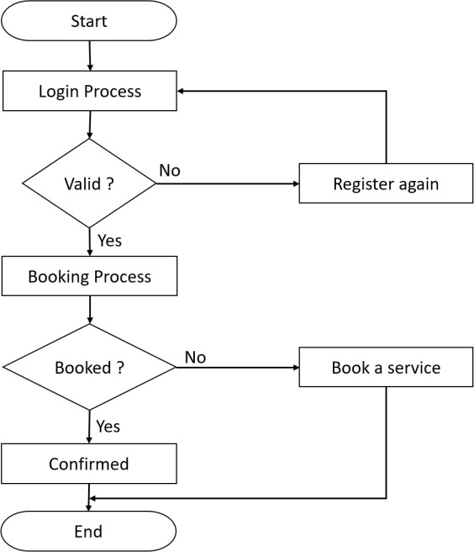 **6.3.1 Logic Diagram**

Figure 6.3.1: System Flow of the project

**6.3.2 Data Structures**

Tree: Tree represents the nodes connected by edges. We will discuss binary tree or binary search tree specifically.

*Algorithm-*

If root is NULL

then create root node return

If root exists then

compare the data with node.data

while until insertion position is located If data is greater than node.data

goto right subtree else

goto left subtree

endwhile insert data

end If

*Stack:* A stack is an Abstract Data Type (ADT), commonly used in most programming languages. It is named stack as it behaves like a real-world stack, for example – a deck of cards or a pile of plates, etc.

*Algorithm for peek()-*

begin procedure peek return stack[top]

end procedure

*Algorithm for isfull()-*

begin procedure isfull

if top equals to MAXSIZE return true

else

return false endif

end procedure

*Algorithm for isEmpty()-*

begin procedure isempty if top less than 1

return true else

return false endif

end procedure

**6.3.3 Algorithm Design**

The below algorithm is implemented in the E –Booking System of Services.

Step 1: Start.

Step 2: Login into the system using the Credentials provided by the Admin in registered. Step 3: If not registered, then get registered by Admin.

Step 4: After getting registered Login into the system using the credentials provided.

Step 5: After logging in into the system using correct credentials, book for your preferred service provider.

Step 6: The booking won’t be possible if details are wrongly inserted.

Step 7: Once the booking is done you will able to see the various service providers. Step 8: Book your services.

Step 9: Logout of the System. Step 10: Stop.

## 6.4 User Interface Design

**6.4.1 Home Page of the System**

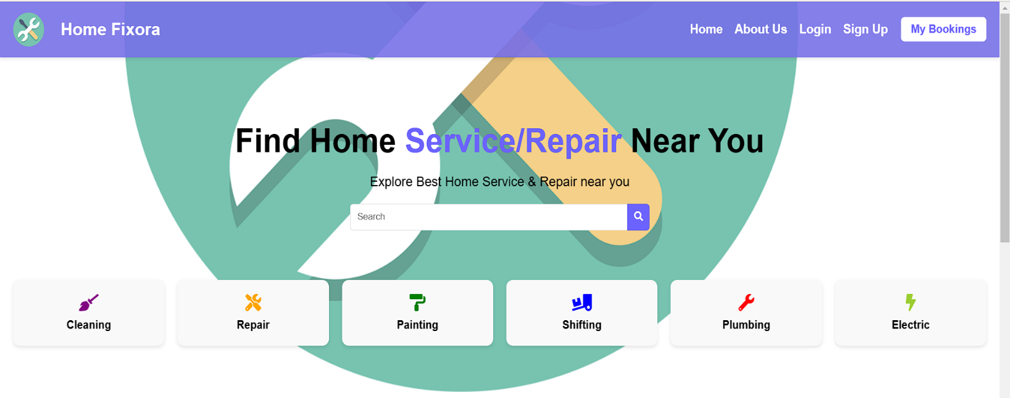

Figure 4.4.1: Home Page of the System

The Home Page of the system will consist of a Home Button, Login Button and Registration Button on the upper right-hand corner. It will also display the various service provider. After clicking on those service providers it will display the information of the service providers.

**6.4.2 Services**

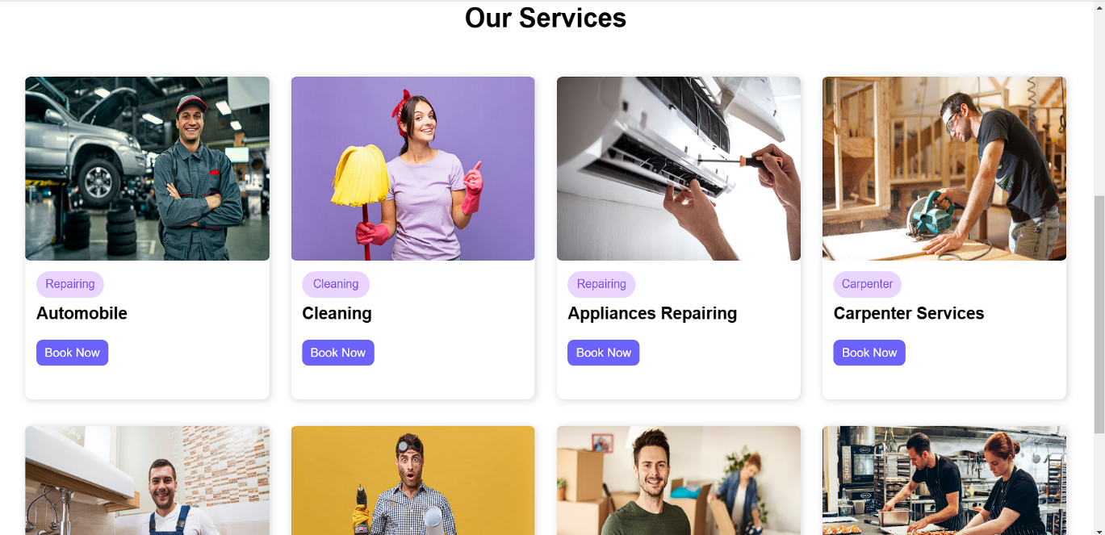

**6.4.3 Customer Login Page**

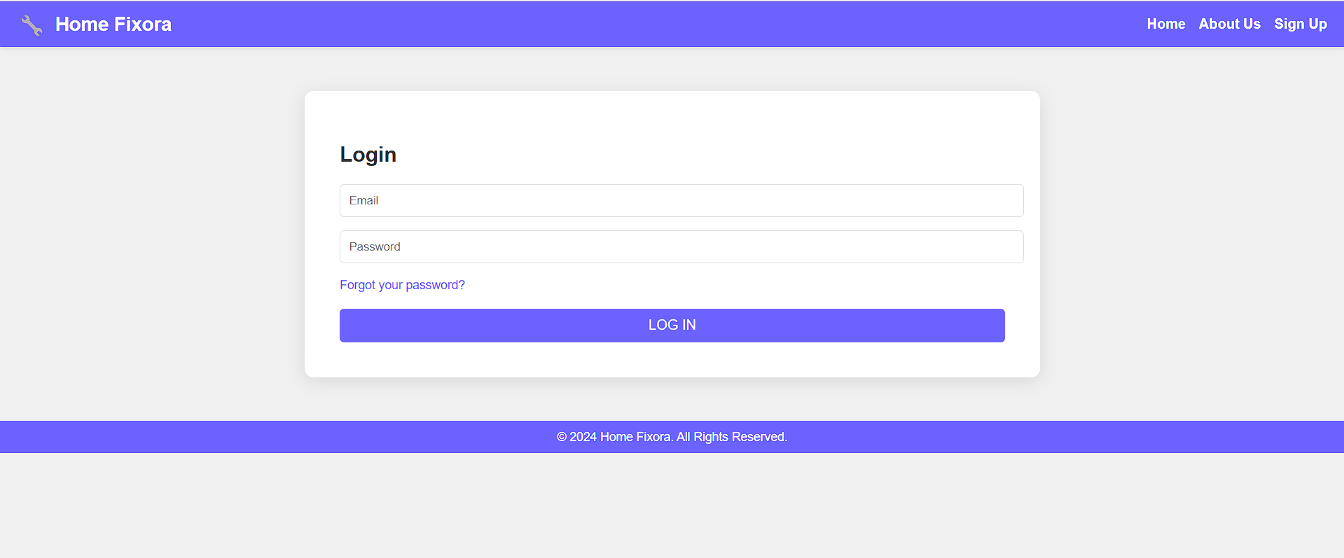

**6.4.4 Customer Registration Page**

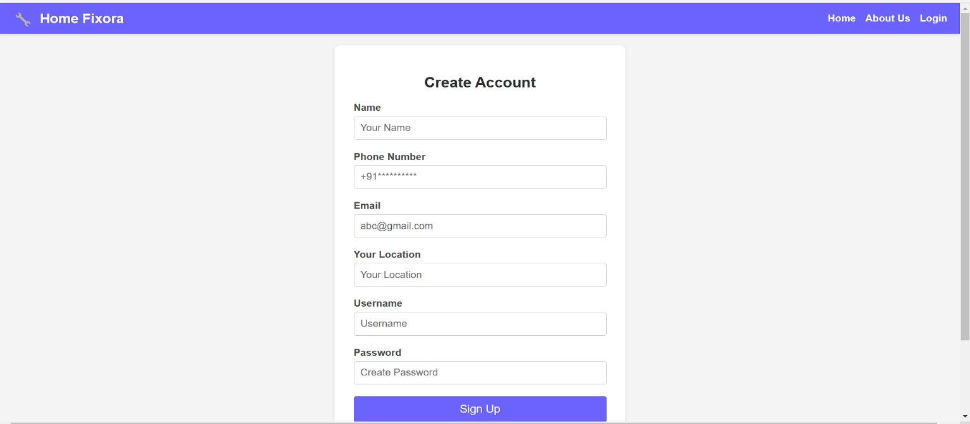

Figure 6.4.4: Customer Registration Page of the System

When the Customer is new to this website he/she needs to register first with their details as mentioned in the Signup page like Name, Phone, E-Mail Id, Location.

And after filling these details, he/she needs to create a password for this website.

### Reference

#### Established Platforms

1. **Angi**: A platform offering a large network of verified professionals for various home services. Users can access verified reviews and ratings for better decision-making.
2. **Thumbtack**: Known for its wide range of services, Thumbtack connects users with professionals for everything from repairs to wedding planning. Transparent pricing and fast booking are key features.
3. **HomeAdvisor**: Specializes in home improvement projects, offering tools for cost estimation and project planning alongside professional services.
4. **Task Rabbit**: Primarily for smaller tasks, such as furniture assembly or minor repairs, Task Rabbit provides a simple way to book on-demand services.

#### Additional Platforms

* **Porch**: Focused on large-scale home improvement projects, Porch integrates with retailers like Lowe’s to provide professional installation services.
* **Handy**: Handy specializes in cleaning and small home maintenance tasks, providing a quick and efficient booking process.
* **Next door**: A community-based platform where neighbors can share recommendations for local service providers.

**Websites**

* Geeksforgeeks.com
* Javatpoint.com
* W3school.com
* Mdndocs.com

**Books**

* You don’t know JS -By Kyle
* A Smarter way to Learn Javascript –By Mark Myers